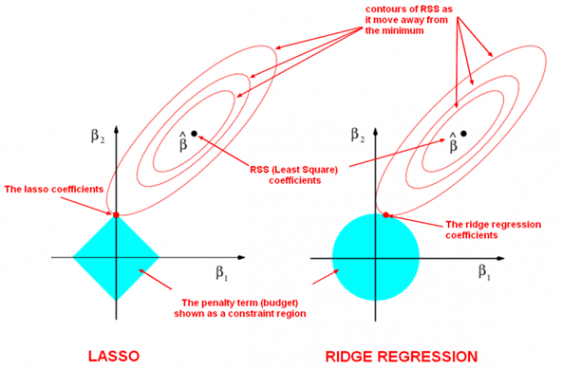

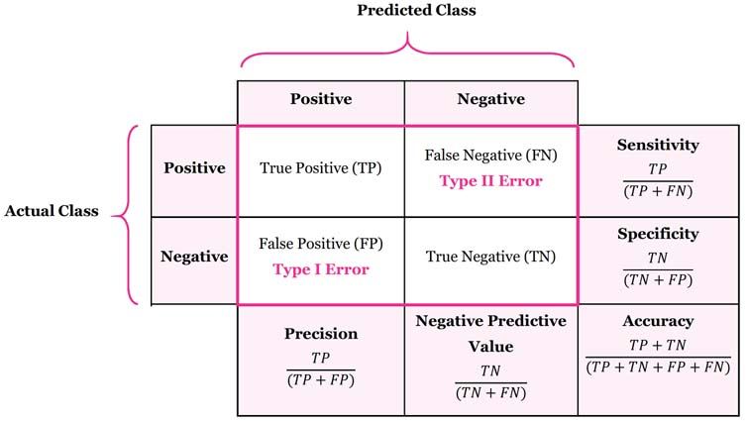

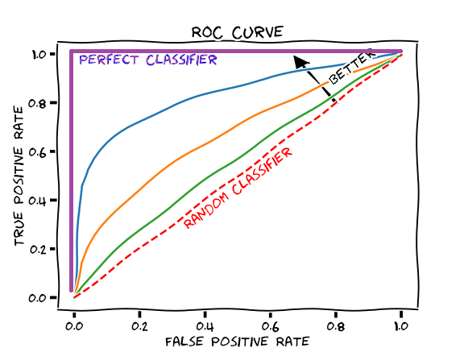

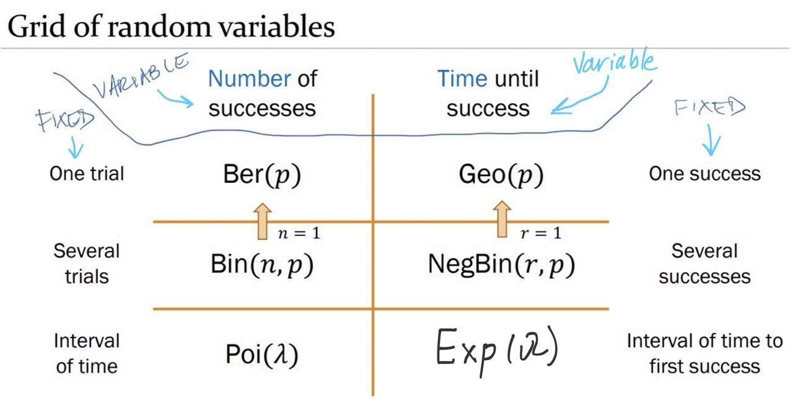

|  |  |
| --- | --- |
| # [Inclusive, Inclusive]  random.randint(**1**,**3**) | # [Inclusive, Exclusive)  np.random.randint(**1**, **3**, size=**5**) |
| random.uniform(**1**,**3**) | np.random.uniform(**1**, **3**, size=**5**) |
| random.gauss(**0**, **1**) | np.random.normal(**0**, **1**, size=**5**) |
| # With Replacements  random.choices(['a','b','c'], k=**2**) | np.random.choice(['a','b','c'],  size=**5**, replace=**True**) |
| # Without Replacements  random.sample(['a','b','c'], k=**2**) |

